**// Передача по значению**

**// Инкремент числа**

#include <iostream>

using namespace std;

int incr1(int a, int c);

int incr2(int *pa, int c);

int main()

{

int a=1;

int c;

cout<<" input c:";

cin>>c; cout<<endl;

cout<< " function incr1 : "<<incr1(a,c)<<endl;

cout<<" a= "<<a<<endl;

int *pa;

pa=&a;

cout<< " function incr2 : "<<endl;

cout <<" pa= "<< pa<<" &a= "<<&a<< endl;

cout<<" a= " << a<< endl;

cout<<endl;

cout <<" incr2(pa, c) : "<<incr2(pa, c) <<endl;

cout<<" a= "<<a<<endl;

return 0;

}

int incr1(int a,int c)

{

a+=c;

return a;

}

int incr2(int *pa,int c)

{

cout <<" pa= "<< pa<<endl;

*pa+=c;

return *pa;

}

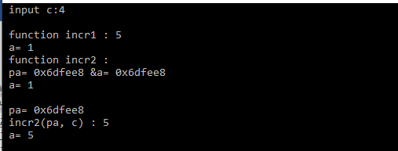

**// Передача по ссылке**

#include <iostream>

using namespace std;

int incr3(int& ra,int c);

int main()

{

int a=1;

int c;

cout<<" input c:";

cin>>c; cout<<endl;

cout << " before : a= "<<a<<endl;

int& ra=a;

cout <<" incr3(ra, c): "<<incr3(ra, c)<< endl;

cout<<" after : a= " <<a<< endl;

return 0;

}

int incr3(int& ra,int c)

{

ra+=c;

return ra;

}

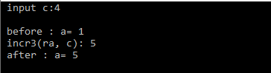

**//Передача по значению и по ссылке**

#include <iostream>

using namespace std;

int incr1(int a,int c);

int incr2(int *pa,int c);

int incr3(int& ra,int c);

int main()

{

int a=1;

int c;

cout<<" input c:";

cin>>c; cout<<endl;

cout<< " function incr1 : "<<incr1(a,c)<<endl;

cout<<" a= "<<a<<endl;

int *pa;

pa=&a;

cout<< " function incr2 : "<<endl;

cout <<" pa= "<< pa<<" &a= "<<&a<< endl;

cout<<" a= " << a<< endl;

cout<<endl;

cout <<" incr2(pa, c) : "<<incr2(pa, c) <<endl;

cout<<" a= "<<a<<endl;

cout<<endl;

cout << " before : a= "<<a<<endl;

int& ra=a;

cout <<" incr3(ra, c): "<<incr3(ra, c)<< endl;

cout<<" after : a= " <<a<< endl;

return 0;

}

int incr1(int a,int c)

{

a+=c;

return a;

}

int incr2(int *pa,int c)

{

cout <<" pa= "<< pa<<endl;

*pa+=c;

return *pa;

}

int incr3(int& ra,int c)

{

ra+=c;

return ra;

}

